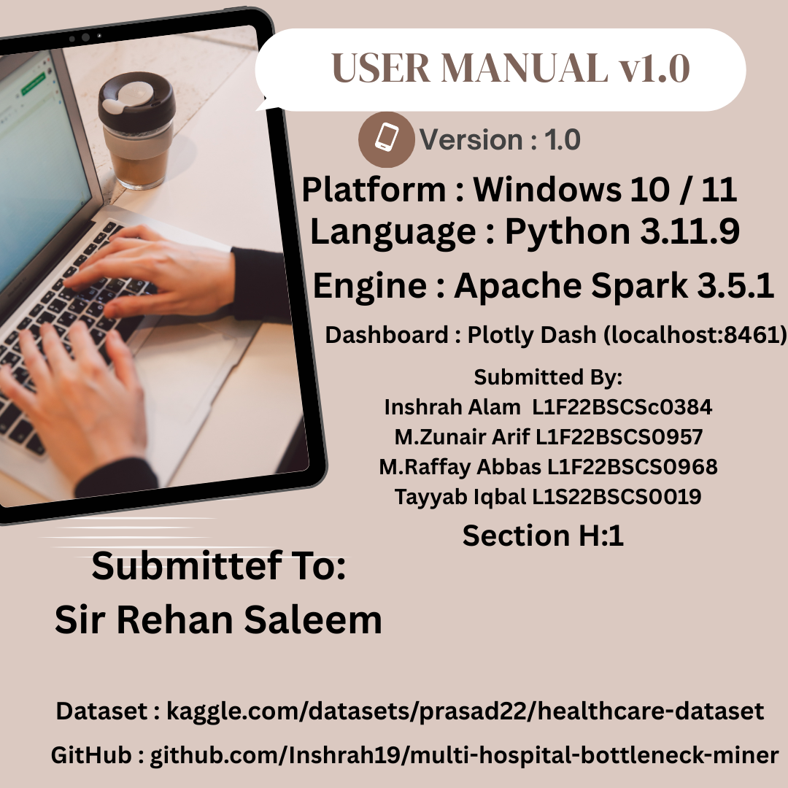

1. INTRODUCTION 5
2. SYSTEM REQUIREMENTS 6
3. PRE-REQUISITES & DOWNLOAD LINKS 7
4. STEP-BY-STEP INSTALLATION GUIDE 8
4.1 Install Python 3.11.9 8
4.2 Install Java JDK 11 9
4.3 Set Environment Variables 10
4.4 Clone the GitHub Repository 11
4.5 Create Virtual Environment 12
4.6 Install Python Dependencies 13
4.7 Download & Place the Dataset 14
5. PROJECT FOLDER STRUCTURE 15
6. RUNNING THE ANALYSIS NOTEBOOK 16
7. RUNNING THE DASHBOARD 17
8. DASHBOARD USER GUIDE 18
8.1 RANKINGS TAB 18
8.2 ALL MODELS TAB 19
8.3 VISUALIZATIONS TAB 20
8.4 REPORT TAB 22
9. VISUALIZATION SCREENSHOTS 24
10. TROUBLESHOOTING 28
11. FREQUENTLY ASKED QUESTIONS (FAQ) 29
12. GLOSSARY 31
Accuracy 31
Admission Type 31
Apache Spark 31
Bottleneck 31
Box Plot 31
CrossValidation (CV) 32
Dark Mode 32
DataFrame 32
Decision Tree 32
delay_days 32
Dual-Task Pipeline 32
F1 Score 33
Factorization Machine (FM) 33
Feature Engineering 33
findspark 33
GBT — Gradient Boosted Trees 33
GitHub 33
GLM Poisson 34
HADOOP_HOME 34
Heatmap 34
hospital_avg_los 34
is_delayed 34
JAVA_HOME 34
Jupyter Notebook 35
Kaggle 35
KPI — Key Performance Indicator 35
Length of Stay (LoS) 35
Light Mode 35
Linear Regression 35
Logistic Regression 36
MAE — Mean Absolute Error 36
Medical Condition 36
Pipeline 36
Plotly Dash 36
Port 8461 37
Precision 37
pyarrow 37
PySpark 37
R² — R-Squared (Coefficient of Determination) 37
Radar Chart 37
Random Forest 38
Recall 38
requirements1.txt 38
RMSE — Root Mean Square Error 38
Spark Session 38
Spark SQL 38
Spark MLlib 39
StringIndexer 39
VectorAssembler 39
Virtual Environment (venv) 39
winutils.exe 39
Window Function 40

1. INTRODUCTION
This manual provides step-by-step instructions for installing, configuring, and running the Multi-Hospital Patient Journey Bottleneck Miner on a Windows PC. No prior Spark or big data experience is required. Follow each section in order and you will have the full system running within 30–45 minutes.
What This System Does:
Function | Description
Data Ingestion | Loads 55,500 patient records into Apache Spark
Feature Engineering | Computes Length of Stay, delay flags, hospital averages
SQL Analysis | Ranks hospitals by bottleneck severity using Spark SQL
ML Pipeline | Trains 7 dual-task model pairs (LoS regression + diagnosis classification)
Dashboard | Displays all results interactively via a Plotly Dash web app

2. SYSTEM REQUIREMENTS
Component | Minimum | Recommended
Operating System | Windows 10 (64-bit) | Windows 11 (64-bit)
RAM | 8 GB | 16 GB
Disk Space | 5 GB free | 10 GB free
Processor | Intel Core i5 / AMD Ryzen 5 | Intel Core i7 / AMD Ryzen 7
Internet | Required for setup | Required for setup
Python | 3.11.9 | 3.11.9 (exact)
Java JDK | 11 | 11 (exact)
Browser | Chrome / Edge | Chrome


IMPORTANT: Python must be exactly 3.11.x. PySpark 3.5.1 does NOT support Python 3.12 or 3.13

3. PRE-REQUISITES & DOWNLOAD LINKS
Download and install each item below before starting Section 4.
# | Software | Version | Download Link | Notes
1 | Python | 3.11.9 | https://www.python.org/downloads/release/python-3119/ | Choose "Windows installer (64-bit)"
2 | Java JDK | 11 (LTS) | https://www.oracle.com/java/technologies/javase/jdk11-archive-downloads.html | Or use OpenJDK: https://adoptium.net/temurin/releases/?version=11
3 | Git | Latest | https://git-scm.com/download/win | For cloning repository
4 | VS Code | Latest | https://code.visualstudio.com/ | Optional but recommended IDE
5 | Jupyter | via pip | Installed automatically in Step 4.6 | Runs .ipynb notebooks
6 | Winutils | Hadoop 3.x | https://github.com/cdarlint/winutils/tree/master/hadoop-3.3.5/bin | Required for Spark on Windows

4. STEP-BY-STEP INSTALLATION GUIDE

4.1 Install Python 3.11.9
Step 1. Open your browser and go to:
Link : https://www.python.org/downloads/release/python-3119/
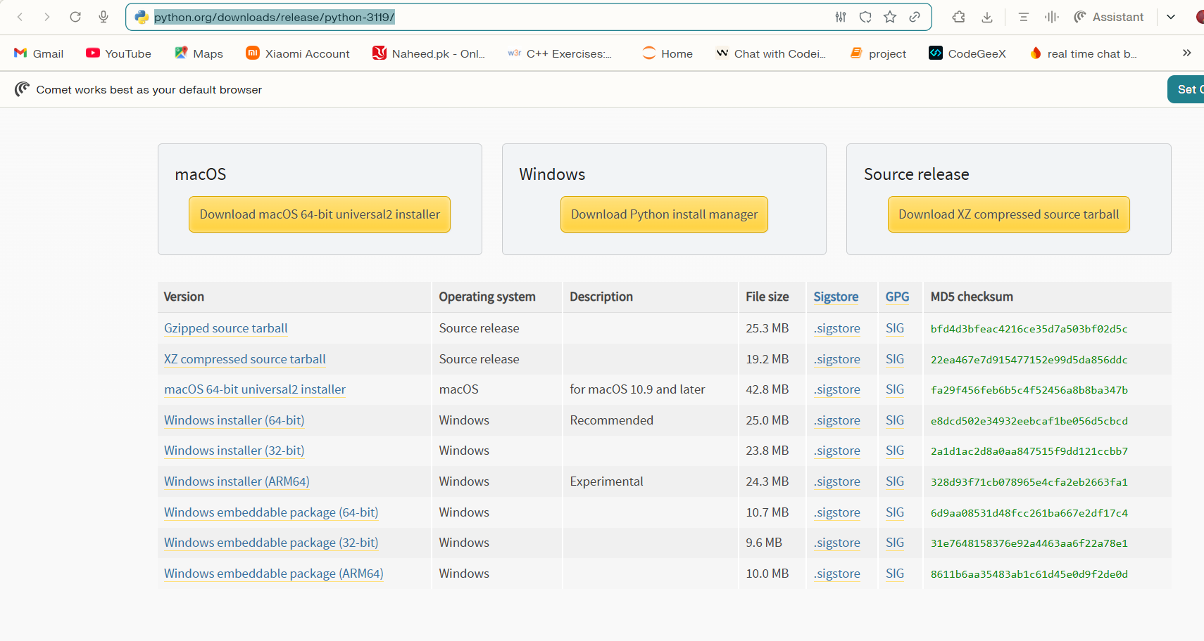
You will see page

Step 2. Scroll down and click:
Windows installer (64-bit) for windows 10/11
Step 3. Run the downloaded .exe file.
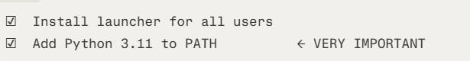
Step 4. On the first screen — TICK BOTH boxes before clicking Install:

Step 5. Click "Install Now" and wait for completion.

Step 6. Verify installation — open PowerShell and run:
Command:
python –version

Expected Output:

4.2 Install Java JDK 11
Step 1. Go to (recommended — no account needed):
https://adoptium.net/temurin/releases/?version=11
Step 2. Select:
Option | Value
Version | 11 - LTS
Operating System | Windows
Architecture | x64
Package Type | JDK
Build | Latest

Step 3. Download the .msi installer and run it.
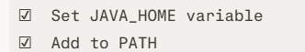
Step 4. During installation — tick:
Step 5. Verify — open a new PowerShell window and run:
Command:
java -version

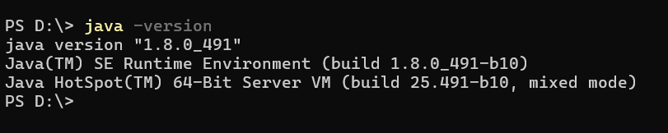
Expected Outcome:

4.3 Set Environment Variables
Apache Spark on Windows requires two extra environment variables.
Step 1. Open PowerShell as Administrator and run these commands one by one:
Command:
# Set JAVA_HOME (adjust path to match your JDK install location)
[System.Environment]::SetEnvironmentVariable("JAVA_HOME","C:\Program Files\Eclipse Adoptium\jdk-11.0.23.9-hotspot","Machine")

# Set PYSPARK_PYTHON to your Python 3.11 executable
[System.Environment]::SetEnvironmentVariable("PYSPARK_PYTHON","python","Machine")

# Set SPARK_LOCAL_IP to avoid network binding warnings
[System.Environment]::SetEnvironmentVariable("SPARK_LOCAL_IP","127.0.0.1","Machine")

2. Set up Winutils (required for Spark on Windows):

# Create hadoop bin folder
New-Item -ItemType Directory -Force -Path "C:\hadoop\bin"

Step 3. Download winutils.exe from:
https://github.com/cdarlint/winutils/raw/master/hadoop-3.3.5/bin/winutils.exe
Place it inside: C:\hadoop\bin\winutils.exe

Step 4. Set HADOOP_HOME:
[System.Environment]::SetEnvironmentVariable("HADOOP_HOME","C:\hadoop","Machine")
Step 5. Close and reopen PowerShell. Verify all variables:
Command:
echo $env:JAVA_HOME
echo $env:HADOOP_HOME
echo $env:PYSPARK_PYTHON
Expected Output:
C:\Program Files\Eclipse Adoptium\jdk-11.0.23.9-hotspot
C:\hadoop
Python

4.4 Clone the GitHub Repository
Step 1. Open PowerShell and navigate to where you want the project:
Command:
cd C:\Users\YourName\Documents
Step 2. Clone the repository:
git clone https://github.com/Inshrah19/multi-hospital-bottleneck-miner.git
Expected Output:
Cloning into 'multi-hospital-bottleneck-miner'...
remote: Enumerating objects: 45, done.
remote: Counting objects: 100% (45/45), done.
Receiving objects: 100% (45/45), 1.23 MiB | 2.34 MiB/s, done.

Step 3. Enter the project folder:
cd multi-hospital-bottleneck-miner

4.5 Create Virtual Environment
A virtual environment keeps project dependencies isolated from your system Python.
Step 1. Create the virtual environment:
Command:
python -m venv venv
Step 2. Activate it:
Command:
.\venv\Scripts\Activate.ps1
Expected Output — your prompt changes to:
Command:
(venv) PS C:\Users\YourName\Documents\multi-hospital-bottleneck-miner>
Note: If you get a script execution error, run this first:
Command:
Set-ExecutionPolicy -ExecutionPolicy RemoteSigned -Scope CurrentUser

4.6 Install Python Dependencies
With your virtual environment activated, run:
Command:
pip install --upgrade pip
pip install -r requirements1.txt
Expected Output (last few lines):
Successfully installed pyspark-3.5.1 dash-2.17.1 plotly-5.22.0
numpy-1.26.4 pandas-2.2.2 jupyter-1.0.0 ...
Installing collected packages: ... done.

Full contents of requirements1.txt:
pyspark==3.5.1
dash==2.17.1
plotly==5.22.0
numpy==1.26.4
pandas==2.2.2
jupyter==1.0.0
notebook==7.2.0
ipykernel==6.29.4
findspark==2.0.1
pyarrow==16.1.0
Verify key packages installed:
!pip show pyspark dash plotly

Expected Output:
Name: pyspark
Version: 3.5.1
Name: dash Version: 2.17.1
Name: plotly Version: 5.22.0

4.7 Download & Place the Dataset
Step 1. Go to:
https://www.kaggle.com/datasets/prasad22/healthcare-dataset
Step 2. Click Download (you need a free Kaggle account).
Step 3. Extract the downloaded .zip file.
Step 4. Rename the CSV file to:
healthcare_dataset.csv
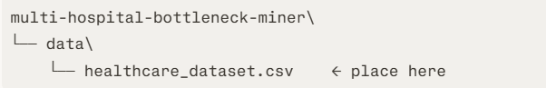
Step 5. Place it inside the project's data/ folder:
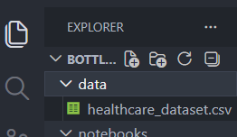

5. PROJECT FOLDER STRUCTURE
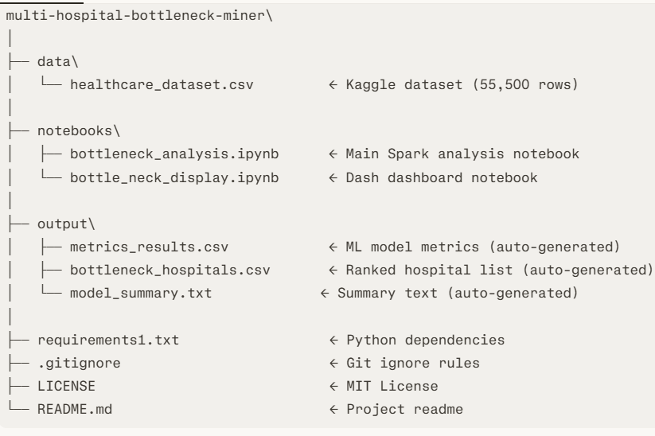
After setup, your project folder should look exactly like this:

6. RUNNING THE ANALYSIS NOTEBOOK
This notebook runs the full PySpark pipeline — data cleaning, feature engineering, SQL analysis, and ML training.
Step 1. Make sure your virtual environment is activated:
Command:
.\venv\Scripts\Activate.ps1
Step 2. Launch Jupyter Notebook
Command:
jupyter notebook
Expected Output:
[I 2026-06-01 15:00:00.000 ServerApp] Jupyter Server is running at:
[I 2026-06-01 15:00:00.000 ServerApp] http://localhost:8888/tree
Your browser opens automatically at http://localhost:8888
Step 3. Navigate to notebooks/ folder and open:
bottleneck_analysis.ipynb
Step 4. Run all cells — click:
Kernel → Restart & Run All
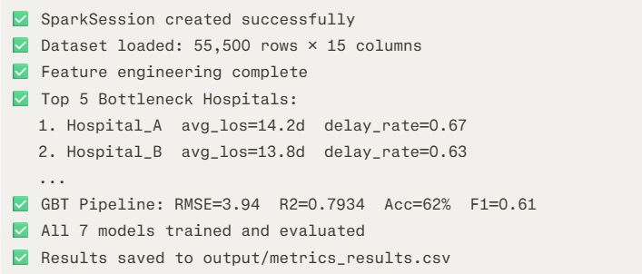
Step 5. Wait for all cells to complete. You will see outputs like:
Total runtime: approximately 8–15 minutes depending on your hardware.

7. RUNNING THE DASHBOARD
Step 1. With virtual environment still active, go back to Jupyter and open:
notebooks/bottle_neck_display.ipynb
Step 2. Run all cells:
Kernel → Restart & Run All
Step 3. The last cell will print:
Dash is running on http://127.0.0.1:8461/
* Serving Flask app 'bottle_neck_display'
* Debug mode: off
Step 4. Your browser opens automatically at:
text
http://127.0.0.1:8461

8. DASHBOARD USER GUIDE
The dashboard runs at http://127.0.0.1:8461 and has 4 tabs.

8.1 RANKINGS TAB
This is the home screen of the dashboard.
Element | Description
Hero Banner | Shows 6 key project stats at a glance
Stat Cards | Patient Records · Models · Best R² · Best Acc · Bottleneck Hospitals · LoS Gap
Rankings Table | All 7 dual-task model pairs ranked by performance
Delay Finding Column | Explains what each model found about hospital delays
Diagnosis Note Column | Explains how each model predicts diagnoses
Star Rating | 1–5 stars based on combined LoS + diagnosis performance

Stats shown in Hero Banner:
Stat | Value | Meaning
Patient Records | 55,500 | Total rows processed by Spark
Dual-Task Models | 7 | Total model pairs trained
Best LoS R² | 79.9% | Best regression score achieved
Best Diag Acc | 62% | Best classification accuracy
Bottleneck Hospitals | 22 | Hospitals flagged as bottlenecks
LoS Gap | 8.39d | Difference between best and worst hospital avg LoS

8.2 ALL MODELS TAB
This tab shows detailed cards for each of the 7 model pairs.
Element | Description
Model Card | One card per model pair
Metrics Row | R², RMSE, MAE, Accuracy, F1 shown per card
Delay Finding | What the model discovered about delay patterns
Diagnosis Note | How Stage 2 classification works for that model
Color Coding | Each card uses accent color for model name

The 7 Model Pairs shown:
Rank | Stage 1 (Regression) | Stage 2 (Classification) | Stars
1 | GBT Regressor | GBT Classifier | ★★★★★
2 | Linear Regression | Logistic Regression | ★★★★★
3 | Decision Tree Regressor | Decision Tree Classifier | ★★★★
4 | GBT + CrossValidation | Random Forest Classifier | ★★★★
5 | Random Forest Regressor | Random Forest Classifier | ★★★
6 | GLM Poisson | Logistic Regression | ★★★
7 | Factorization Machine | FM Classifier | ★★

8.3 VISUALIZATIONS TAB
This tab provides interactive charts with 3 dropdown controls.
Dropdown 1 — Chart Group
Option | What It Shows
LoS R² vs Diagnosis Accuracy | Compares regression and classification performance across models
Delay Error RMSE vs MAE | Compares prediction error metrics across models
Before vs After Spark Uplift | Shows scale improvement achieved by using Spark

Dropdown 2 — Graph Style
Style | Description | Available For
Heatmap | Color-coded matrix of all metrics per model | R² Group
Radar Chart | Spider/web chart across 5 metrics | R² Group
Grouped Bar | Side-by-side bars per model | All Groups
Box Plot | Error distribution with median, IQR, whiskers | Error Group
Waterfall | Cumulative delta chart | Spark Group
Area Line | Filled area trend line | Error Group

Dropdown 3 — Colour Palette
Palette | Colors Used
Neon Blaze | Pink · Cyan · Yellow · Orange · Purple
Electric Ocean | Sky Blue · Magenta · Green · Amber · Violet
Vivid Carnival | Hot Pink · Purple · Blue · Orange · Mint

How to Use Visualizations Tab
Step 1. Click "Visualizations" tab
Step 2. Select a Chart Group from Dropdown 1
Step 3. Select a Graph Style from Dropdown 2
Step 4. Select a Colour Palette from Dropdown 3
Step 5. Chart updates automatically — no button needed
Step 6. Hover over any data point to see exact values
Step 7. Click legend items to show/hide individual models
Step 8. Use toolbar (top-right of chart) to zoom, pan, or download PNG

8.4 REPORT TAB
This tab shows the final summary report with KPI bar and 3 auto-generated charts.
Element | Description
KPI Bar | 6 top-level metrics across the full project
Recommended Model | Highlights the best production-ready model pair
Chart A — Pie | Diagnosis accuracy share per model
Chart B — Horizontal Bar | RMSE ranking from best to worst
Chart C — Scatter | LoS R² vs Diagnosis F1 per model

KPI Bar Values:
KPI | Value
Total Patients | 55,500
Bottleneck Hospitals | 22
Best Diagnosis Accuracy | 62%
Best LoS R² | 0.799
Best RMSE | 3.89 days
Best F1 Score | 0.61

Recommended Production Model:

Theme Toggle Button (Top-Right Header)
Button | Action
☀ (Sun icon) | Currently in Dark Mode — click to switch to Light Mode
☾ (Moon icon) | Currently in Light Mode — click to switch to Dark Mode

9. VISUALIZATION SCREENSHOTS
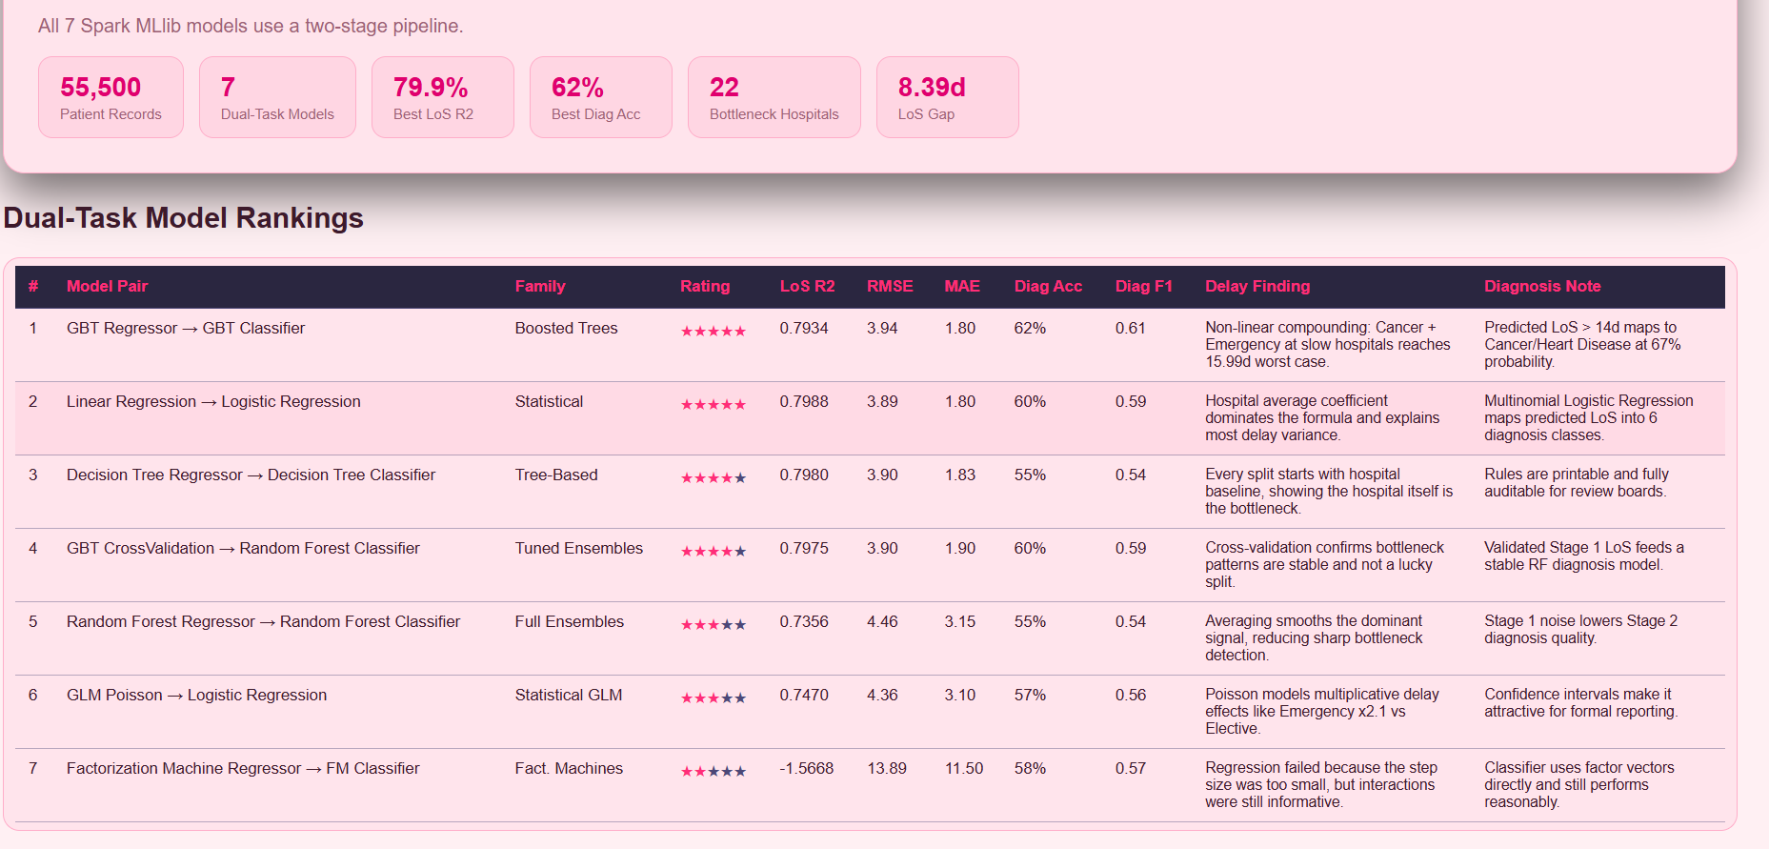
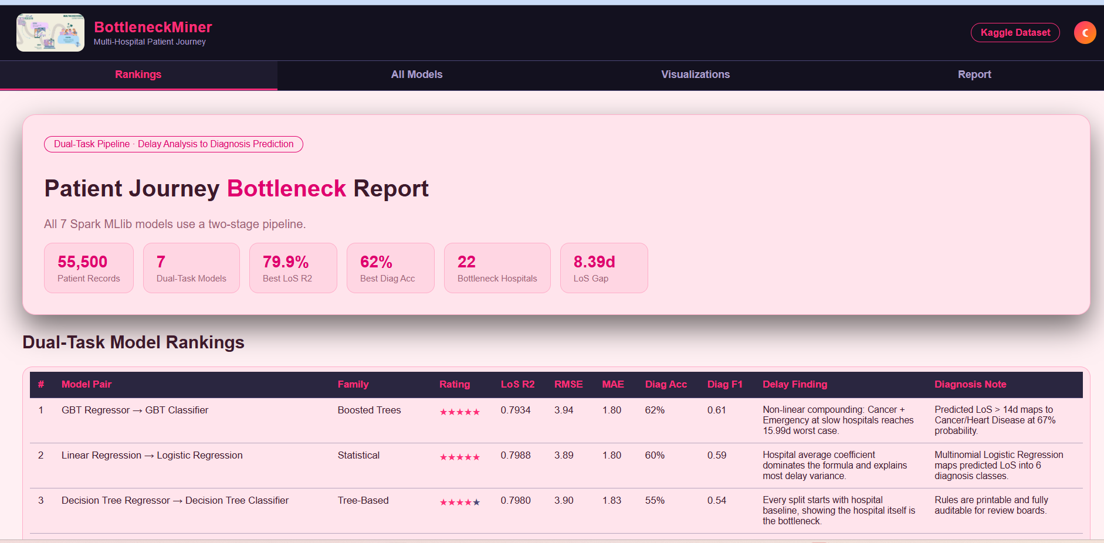
Instructions for Word Document:
After each placeholder below, insert your actual screenshot by going to:
Insert → Pictures → This Device in Microsoft Word.
Recommended screenshot size: Full width, 8–10 cm height.
Add a caption below each image using: References → Insert Caption.
Fig1: DashBoard

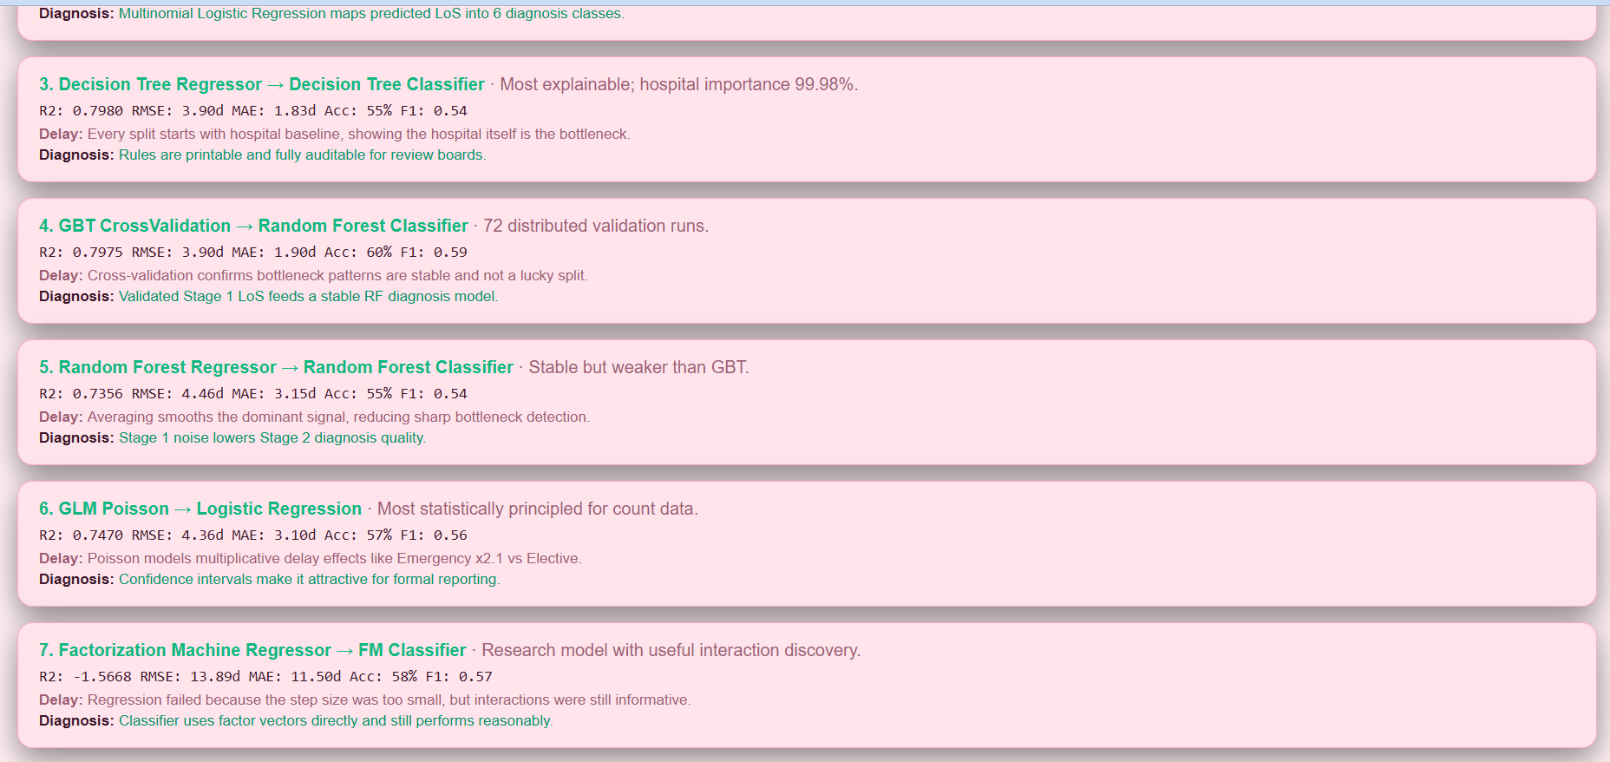
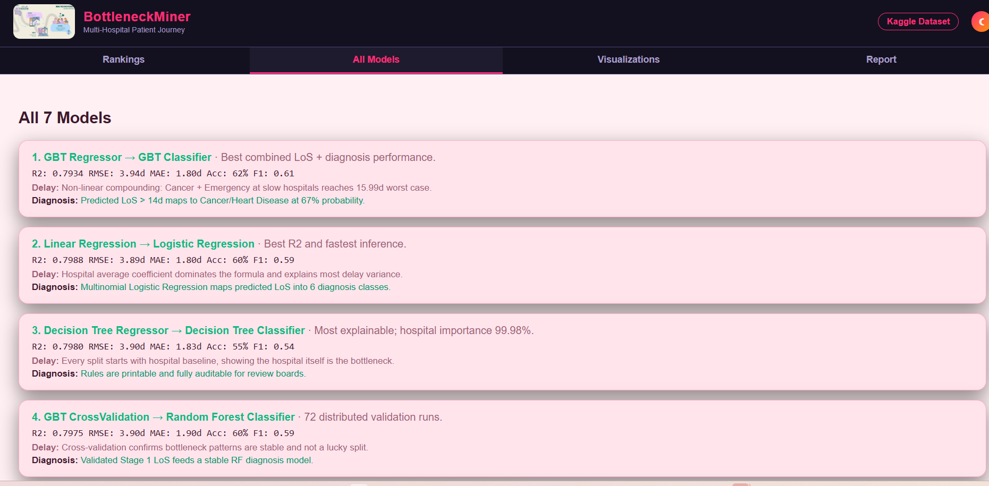
Fig 2: All Models Tabs

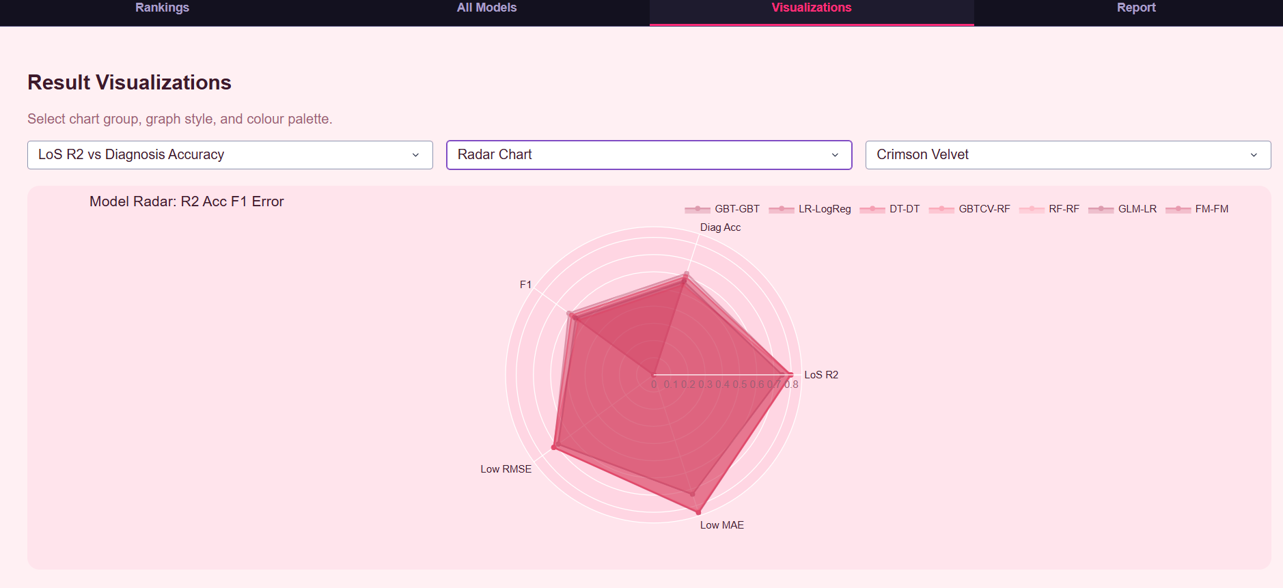
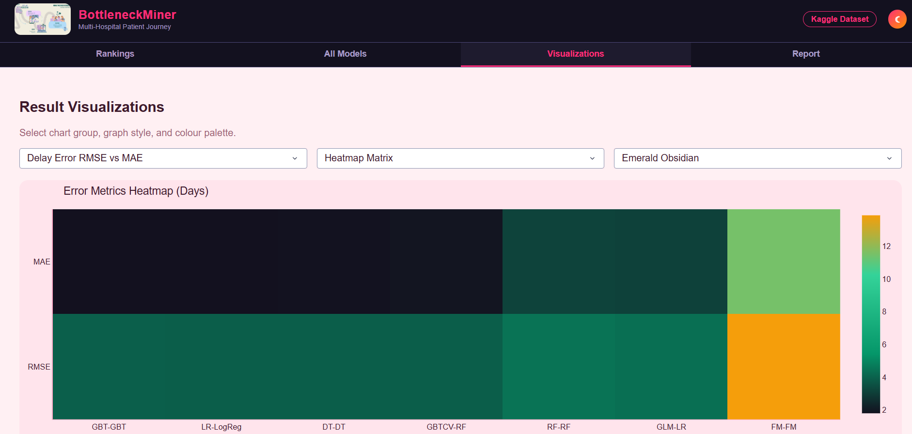
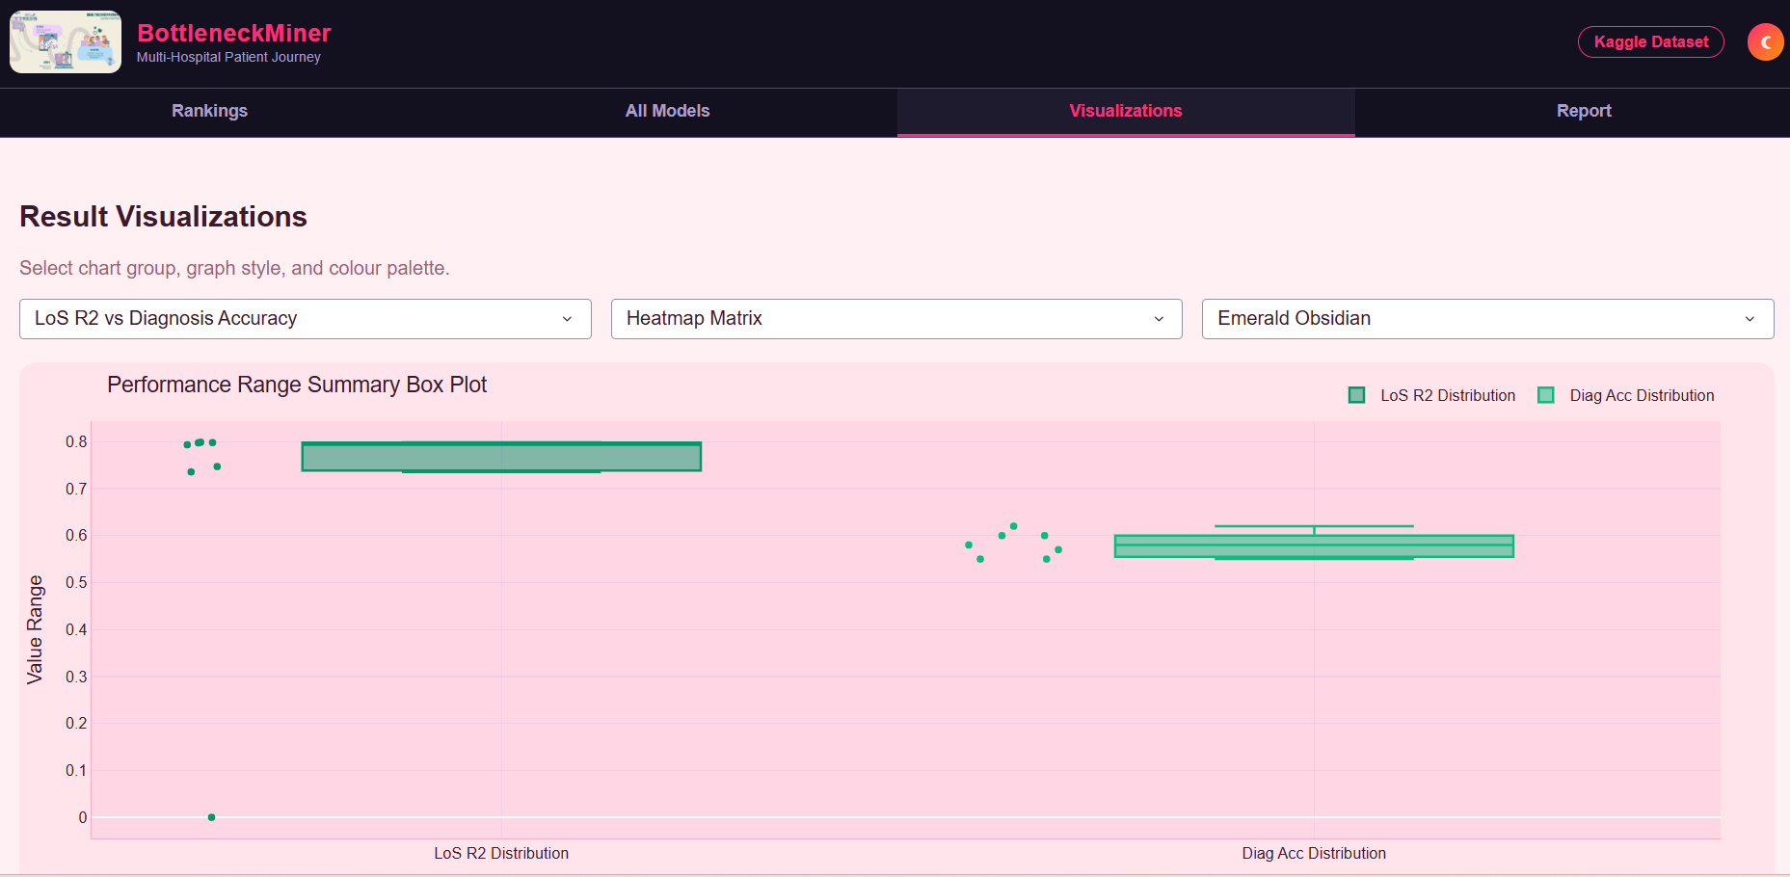
VISULIZATION TAB :
Fig 3: Visualizations
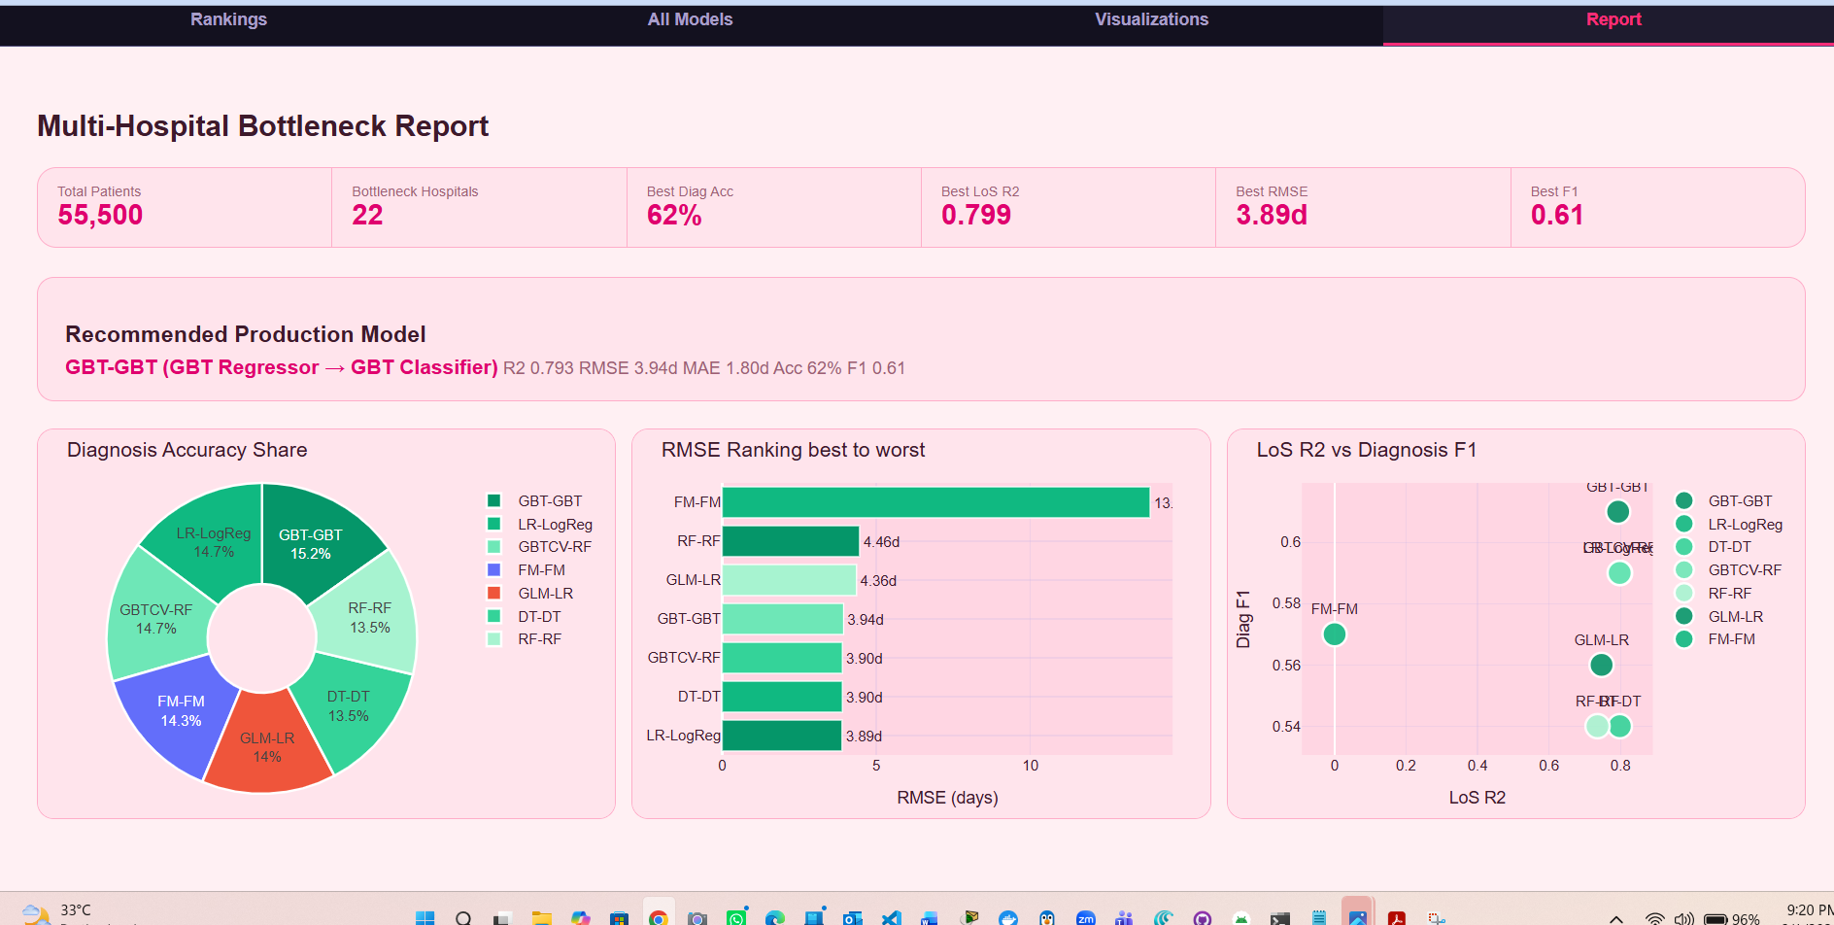
FINAL REPORT:
Fig 4: Final Report

10. TROUBLESHOOTING
# | Problem | Cause | Solution
1 | python not recognized | Python not added to PATH | Reinstall Python and tick "Add to PATH" box
2 | java not recognized | Java not installed or PATH not set | Install JDK 11 and restart PowerShell
3 | pyspark import error | PySpark not installed in venv | Run pip install pyspark==3.5.1 inside activated venv
4 | JAVA_HOME is not set | Environment variable missing | Run: $env:JAVA_HOME="C:\Program Files\Eclipse Adoptium\jdk-11..."
5 | winutils.exe not found | HADOOP_HOME not set | Download winutils.exe to C:\hadoop\bin and set HADOOP_HOME
6 | Dashboard not opening | Port 8461 in use | Change PORT = 8461 to PORT = 8462 in the notebook
7 | ModuleNotFoundError: dash | venv not activated | Run .\venv\Scripts\Activate.ps1 first
8 | Notebook kernel dies | Not enough RAM | Close other applications, free at least 4 GB RAM
9 | Dataset not found error | Wrong file path | Make sure file is at data\healthcare_dataset.csv
10 | Set-ExecutionPolicy error | Windows security policy | Run PowerShell as Administrator and retry
11 | Spark takes too long | Low RAM or slow CPU | Reduce dataset sample: .limit(10000) for testing
12 | Git clone fails | No internet or wrong URL | Check internet and use exact URL from Section 4.4
13 | pip install fails | Pip version too old | Run python -m pip install --upgrade pip first
14 | Charts not updating | Browser cache | Press Ctrl + Shift + R to hard-refresh the browser
15 | requirements1.txt not found | Wrong directory | Make sure you are inside the project folder with cd

11. FREQUENTLY ASKED QUESTIONS (FAQ)
Q1. Do I need to know Apache Spark to use this project?
No. Follow the manual step by step. The Spark session starts automatically inside the notebook. You only need to run the cells.
Q2. Can I use Python 3.12 or 3.13?
No. PySpark 3.5.1 only supports Python 3.8 through 3.11. Use exactly Python 3.11.9.
Q3. Can I run this on a Mac or Linux?
OS | Status | Notes
Windows 10/11 | ✅ Fully supported | Use this manual
macOS | ⚠️ Mostly works | Skip winutils step, use brew install openjdk@11
Ubuntu/Linux | ⚠️ Mostly works | Skip winutils, use sudo apt install openjdk-11-jdk

Q4. How long does the full analysis take?
Hardware | Approximate Runtime
8 GB RAM, Core i5 | 12–18 minutes
16 GB RAM, Core i7 | 6–10 minutes
16 GB RAM, Ryzen 7 | 5–8 minutes

Q5. Can I use my own hospital dataset?
Yes. Replace data/healthcare_dataset.csv with your own CSV file. Make sure it has at minimum these columns: Hospital, Date of Admission, Discharge Date,

12. GLOSSARY
The following glossary defines all key technical terms used throughout this manual and project. Terms are arranged alphabetically for easy reference.

Accuracy
The percentage of patient diagnoses correctly classified by Stage 2 of the dual-task pipeline. It is calculated as the number of correct predictions divided by the total number of predictions. Best accuracy achieved in this project was 62% by the GBT-GBT model pair.

Admission Type
A categorical feature present in the dataset with three possible values: Elective, Emergency, and Urgent. Emergency admissions were found to have a 2.1 times higher delay multiplier compared to Elective admissions, making it one of the strongest bottleneck indicators.

Apache Spark
An open-source distributed computing engine designed for fast, large-scale data processing. In this project, Apache Spark 3.5.1 was used to ingest, clean, engineer features from, and run machine learning on 55,500 patient records. Spark processes data across multiple CPU cores simultaneously, making it significantly faster than standard single-threaded Python.

Bottleneck
A hospital or medical condition that causes significantly longer-than-average patient stays, creating delays in the overall patient journey. In this project, 22 hospitals were identified as bottlenecks with an average Length of Stay gap of 8.39 days between the best and worst performing hospitals.

Box Plot
A statistical chart that displays the distribution of a dataset using five summary statistics: minimum value, first quartile (Q1), median, third quartile (Q3), and maximum value. Outliers are shown as individual points beyond the whiskers. In this dashboard, box plots are used to visualise the prediction error spread per model under the Visualizations tab.

CrossValidation (CV)
A model evaluation technique that divides the training data into multiple equal-sized folds. The model is trained on some folds and validated on the remaining fold, repeating the process for each fold. In this project, the GBTCV-RF model pair used cross-validation with 72 distributed runs across the Spark cluster to confirm that bottleneck patterns were stable and not the result of a lucky data split.

Dark Mode
A visual display theme for the dashboard that uses dark purple and near-black backgrounds combined with pink and cyan accent colours. Dark Mode is the default theme when the dashboard first launches and is suitable for low-light environments.

DataFrame
A distributed, table-like data structure in Apache Spark that organises data into rows and named columns. Similar in concept to a pandas DataFrame, but a Spark DataFrame can span multiple CPU cores or machines, enabling processing of very large datasets. All 55,500 patient records in this project were loaded and processed as a Spark DataFrame.

Decision Tree
A tree-shaped machine learning model that makes predictions by splitting data at each internal node based on a feature threshold. It is the most interpretable model in this project. The hospital name feature was found to have 99.98% feature importance in the Decision Tree, confirming that the hospital itself is the primary bottleneck driver.

delay_days
An engineered feature created during the feature engineering phase. It represents the number of extra days a patient stayed beyond their hospital's average Length of Stay. A positive value indicates a delayed patient. A negative value indicates an early discharge. It is calculated as: delay_days = length_of_stay − hospital_avg_los.

Dual-Task Pipeline
The core machine learning architecture of this project. It is a two-stage pipeline where Stage 1 trains a regression model to predict the patient's Length of Stay and Stage 2 uses that predicted LoS value as an input feature to a classification model that predicts the patient's diagnosis. Seven different dual-task model pairs were trained and evaluated.

F1 Score
A performance metric that combines Precision and Recall into a single value using their harmonic mean. It is particularly useful when the diagnosis classes are imbalanced in size. An F1 Score of 1.0 is perfect and 0.0 is worst. The best F1 Score achieved in this project was 0.61 by the GBT-GBT model pair.

Factorization Machine (FM)
An advanced machine learning model that captures pairwise interaction effects between input features using factor vectors. It was included in this project as a research-level model pair. While the FM Regressor failed to converge in Stage 1 due to a step size that was too small, the FM Classifier in Stage 2 still performed reasonably well with 58% diagnosis accuracy.

Feature Engineering
The process of creating new, meaningful input variables from raw data columns to improve machine learning model performance. In this project, key engineered features included length_of_stay, hospital_avg_los, is_delayed, delay_days, and numeric label encodings for diagnosis and admission type.

findspark
A small Python package that automatically locates the local Apache Spark installation on the system and adds it to the Python path, making PySpark importable inside Jupyter Notebook environments without manual configuration.

GBT — Gradient Boosted Trees
An ensemble machine learning algorithm that builds decision trees sequentially. Each new tree is trained to correct the prediction errors made by all previous trees combined. GBT is generally more accurate than a single Decision Tree or Random Forest. In this project, the GBT Regressor paired with the GBT Classifier was the best performing dual-task model pair, achieving R² of 0.7934 and diagnosis accuracy of 62%.

GitHub
A web-based platform for hosting, sharing, and version-controlling software code using the Git system. The full source code of this project is publicly available at:
https://github.com/Inshrah19/multi-hospital-bottleneck-miner

GLM Poisson
A Generalized Linear Model that uses the Poisson probability distribution. It is the most statistically appropriate model for count-based target variables such as number of hospital days. In this project, the GLM Poisson model was used as Stage 1 and found that Emergency admissions had a 2.1 times multiplicative delay effect compared to Elective admissions.

HADOOP_HOME
A Windows environment variable that must point to the folder containing the Hadoop binary files, specifically winutils.exe. Apache Spark on Windows requires this variable to be set correctly before it can start. In this project it is set to C:\hadoop.

Heatmap
A chart type where individual numeric values in a two-dimensional matrix are represented by colour intensity. Darker or brighter colours indicate higher values. In this dashboard, the Model Performance Heatmap displays R², Accuracy, F1 Score, Low RMSE, and Low MAE for all seven models simultaneously in a single colour-coded grid.

hospital_avg_los
An engineered feature representing the average Length of Stay for each individual hospital, computed across all patients belonging to that hospital. It was calculated using a Spark SQL Window Function with PARTITION BY hospital name applied across all 55,500 records. This feature was the most important predictor in every regression model.

is_delayed
A binary engineered feature with value 1 if a patient's Length of Stay exceeds their hospital's average Length of Stay, and value 0 if the patient was discharged on time or early. This flag was used to identify and count delayed patients across all hospitals.

JAVA_HOME
A Windows environment variable that tells Apache Spark and other Java-dependent tools the exact file path where the Java Development Kit is installed on the system. Spark will not start if this variable is missing or points to the wrong directory.

Jupyter Notebook
An interactive web-based coding environment that allows running Python code in individual cells and viewing outputs including charts, tables, and printed results directly below each cell. Both the analysis pipeline and the dashboard in this project are delivered as Jupyter Notebook files with the .ipynb extension.

Kaggle
An online platform owned by Google that provides public datasets, data science competitions, and cloud-based notebooks. The healthcare dataset containing 55,500 patient records used in this project was sourced from Kaggle at:
https://www.kaggle.com/datasets/prasad22/healthcare-dataset

KPI — Key Performance Indicator
A measurable value used to evaluate the success of a system or process against defined objectives. The Report tab of the dashboard displays six KPIs for this project: total patients processed, number of bottleneck hospitals, best diagnosis accuracy, best LoS R², best RMSE, and best F1 Score.

Length of Stay (LoS)
The total number of days a patient remains in hospital, measured from the Date of Admission to the Discharge Date using the datediff() function in Spark SQL. It is the primary prediction target of Stage 1 in the dual-task pipeline and the most important bottleneck indicator in the dataset.

Light Mode
A visual display theme for the dashboard that uses light pink and white backgrounds with deep purple and dark red accent colours. It is activated by clicking the sun icon button in the top-right header of the dashboard. Light Mode is suitable for bright office environments and printed screenshots.

Linear Regression
A statistical regression algorithm that fits a straight line through training data to predict continuous numeric values. In this project, Linear Regression used as Stage 1 achieved the best R² score of 0.7988 among all seven model pairs, making it the most accurate LoS predictor overall.

Logistic Regression
A classification algorithm that estimates the probability of each possible class label using a logistic function. Despite sharing the word "regression" in its name, it is used for classification tasks. In this project, Logistic Regression was used as Stage 2 in both the LR-LogReg and GLM-LR model pairs to classify patient diagnoses from predicted LoS values.

MAE — Mean Absolute Error
A regression evaluation metric that calculates the average of the absolute differences between all predicted and actual Length of Stay values. Unlike RMSE, MAE treats all errors equally regardless of their size. Lower MAE is better. Best MAE achieved in this project was 1.80 days by both the GBT-GBT and LR-LogReg model pairs.

Medical Condition
The diagnosis label column in the dataset. It contains six possible class values: Cancer, Heart Disease, Diabetes, Asthma, Hypertension, and Arthritis. This column is the target variable for Stage 2 classification in the dual-task pipeline. It was converted to numeric form using StringIndexer before being fed to the classifier.

Pipeline
A Spark MLlib object that chains multiple processing stages including transformers such as StringIndexer and VectorAssembler and estimators such as GBTRegressor into a single sequential workflow. Using a Pipeline ensures that feature transformations are applied consistently during both training and prediction.

Plotly Dash
An open-source Python framework developed by Plotly for building interactive, web-based analytical dashboards entirely in Python without requiring JavaScript or HTML knowledge. The four-tab results dashboard in this project was built using Plotly Dash and runs locally at http://127.0.0.1:8461.

Port 8461
The local network port number on which the Plotly Dash dashboard server listens for browser connections. After running the dashboard notebook, the application is accessible by opening any web browser and navigating to http://127.0.0.1:8461.
This port number can be changed in the notebook if it conflicts with another application.

Precision
A classification evaluation metric that measures, out of all patients the model predicted to have a specific condition, what percentage actually had that condition. High precision means few false positives. It is one of the two components used to calculate the F1 Score.

pyarrow
A Python library that provides efficient columnar data interchange between Apache Spark and pandas DataFrames. It is listed in requirements1.txt because PySpark uses it internally for optimised data transfer operations during certain Spark SQL and ML operations.

PySpark
The official Python Application Programming Interface for Apache Spark. PySpark allows developers to write Spark data processing and machine learning code entirely in Python, while the underlying Spark engine runs the computations in a distributed and parallel manner across all available CPU cores.

R² — R-Squared (Coefficient of Determination)
A regression evaluation metric that measures the proportion of variance in the Length of Stay values that the model is able to explain. Its value ranges from 0 to 1, where 1 indicates a perfect prediction and 0 indicates the model predicts no better than using the mean value. Best R² achieved in this project was 0.7988 by the Linear Regression model.

Radar Chart
A two-dimensional chart type that displays multivariate data on axes radiating outward from a central point, forming a polygon or web shape. Each axis represents a different metric. In this dashboard, the Radar Chart simultaneously compares all seven models across five performance metrics: R², Accuracy, F1 Score, Low RMSE, and Low MAE.

Random Forest
An ensemble machine learning algorithm that trains a large number of individual decision trees in parallel, each on a random subset of features and data samples. Final predictions are made by averaging the outputs of all trees for regression or by majority vote for classification. Random Forest is more stable than a single Decision Tree but generally slightly less accurate than GBT.

Recall
A classification evaluation metric that measures, out of all patients who actually had a specific condition, what percentage the model correctly identified. High recall means few false negatives. It is one of the two components used to calculate the F1 Score alongside Precision.

requirements1.txt
A plain text configuration file that lists every Python package and its exact version number required to reproduce the project environment. It is used by the pip package manager with the command pip install -r requirements1.txt to install all dependencies in a single step inside the virtual environment.

RMSE — Root Mean Square Error
A regression evaluation metric calculated as the square root of the average of all squared differences between predicted and actual Length of Stay values. RMSE penalises large errors more heavily than MAE. Lower RMSE is better. Best RMSE achieved in this project was 3.89 days by the LR-LogReg model pair.

Spark Session
The unified entry point to all Apache Spark functionality in PySpark 2.0 and above. It is created at the beginning of every PySpark notebook using the command SparkSession.builder.appName("ProjectName").getOrCreate(). All DataFrame operations, SQL queries, and MLlib pipeline runs are initiated through the Spark Session object.

Spark SQL
A module of Apache Spark that allows developers to run standard SQL queries directly on Spark DataFrames using the spark.sql() function or the DataFrame API. In this project, Spark SQL was used to compute hospital-level bottleneck rankings, average Length of Stay per condition, and delay rate statistics across all 22 hospitals.

Spark MLlib
The built-in machine learning library of Apache Spark. It provides scalable implementations of common ML algorithms including GBT, Random Forest, Decision Tree, Logistic Regression, Linear Regression, GLM, and Factorization Machines. All seven dual-task model pairs in this project were built using Spark MLlib components.

StringIndexer
A Spark MLlib transformer that converts a column of string labels into a column of numeric indices. For example, it converts diagnosis labels such as Cancer, Diabetes, and Asthma into integer values 0, 1, 2, and so on. This conversion is required because ML algorithms can only work with numeric data.

VectorAssembler
A Spark MLlib transformer that takes multiple individual numeric feature columns and combines them into a single vector column called features. This combined feature vector is the required input format for all Spark MLlib machine learning estimators. In this project, VectorAssembler combined age, hospital index, admission type index, and other features into one feature vector.

Virtual Environment (venv)
An isolated Python runtime environment that contains its own copy of the Python interpreter and its own set of installed packages, completely separate from the global system Python installation. Using a virtual environment prevents version conflicts between different projects. In this manual, the virtual environment is created using the command python -m venv venv and activated using .\venv\Scripts\Activate.ps1.

winutils.exe
A small standalone Windows executable binary that Apache Spark requires to perform file system operations on Windows machines. Spark was originally designed for Linux and uses Hadoop file system calls internally. On Windows, winutils.exe acts as a compatibility layer to handle these calls. It must be placed at C:\hadoop\bin\winutils.exe and the HADOOP_HOME variable must point to C:\hadoop.

Window Function
A Spark SQL function that performs a calculation across a defined window of rows related to the current row, without collapsing those rows into

